ISMS: Internal

Impurity synthesis and purging study report of
CTPM3

Contents
1.0 Executive summary: 6
2.0 Total synthetic scheme: AN14504 7
3.0 Synthetic scheme of CTPM3: 9
4.0 CTPM3 intermediate specifications: 10
4.1 List of in process controls at CTPM3 step: 11
5.0 List of impurities at CTPM3 step: 13
6.0 Impurity synthesis procedure: 16
6.1 1-Hydroxybenzotriazole monohydrate/ HOBt.H₂O: 16
6.2 (6-(Trifluoromethyl)pyridin-3-yl)methyl L-valinate hydrochloride/CTPM2: 17
6.3 1-Hydroxy-7-methyl-1,3-dihydrobenzo[c] [1,2]oxaborole-6-carboxylic acid/CMDO6: 17
6.4 (6-(Fluoromethyl)pyridin-3-yl)methyl (1-hydroxy-7-methyl-1,3-dihydrobenzo[c][1,2]oxaborole-6-carbonyl)-L-valinate/ Impurity-3: 18
6.5 Methyl (1-hydroxy-7-methyl-1,3-dihydrobenzo[c][1,2]oxaborole-6-carbonyl)-L-valinate/Impurity-4: 20
6.6 (6-(Trifluoromethyl)pyridin-3-yl)methyl acetyl-L-valinate/ Impurity-6: 22
6.7 (6-(Difluoromethyl)pyridin-3-yl)methyl (1-hydroxy-7-methyl-1,3-dihydrobenzo[c][1,2]oxaborole-6-carbonyl)-L-valinate/ Impurity-8: 24
6.8 (6-(Trifluoromethyl)pyridin-3-yl)methyl (3-hydroxy-4-(hydroxymethyl)-2-methylbenzoyl)-L-valinate/Impurity-9: 26
6.9 (6-(Trifluoromethyl)pyridin-3-yl)methyl (4-(hydroxymethyl)-2-methylbenzoyl)-L-valinate/Impurity-10: 28
6.10 (6-(Trifluoromethyl)pyridin-3-yl)methyl (1-hydroxy-7-methyl-1,3-dihydrobenzo[c][1,2]oxaborole-6-carbonyl)-L-valyl-L-valinate /Impurity-12a: 30
6.11 (6-(Trifluoromethyl)pyridin-3-yl)methyl (1-hydroxy-7-methyl-1,3-dihydrobenzo[c] [1,2]oxaborole-6-carbonyl)-D-valyl-L-valinate/Impurity-12b: 33
6.12 (S)-(6-(((1H-benzo[d][1,2,3]triazol-1-yl)oxy)methyl)-2-methyl-3-((3-methyl-1-oxo-1-((6-(trifluoromethyl)pyridin-3-yl)methoxy)butan-2-yl)carbamoyl)phenyl)boronic acid/Impurity-17: 36
6.13 (S)-N-(1-(cyclohexylamino)-3-methyl-1-oxobutan-2-yl)-1-hydroxy-7-methyl-1,3-dihydrobenzo[c][1,2]oxaborole-6-carboxamide/Impurity-7: 36
7.0 CTPM3 purging studies: 38
7.1 Purging study of CTPM3 impurities (>0.50%) during ethyl acetate-heptane crystallization 38
7.2 Purging study of CMDO6 intermediate >1.0% in CTPM3 reaction mass: 40
7.3 Purging study of CTPM2 intermediate in CTPM3 reaction mass: 41
7.4 Spiking and purging study of Impurity-7 in CTPM3 43
8.0 Overall conclusion: 46
9.0 Annexures: 47
9.1 Annexure-1 (¹H-NMR spectrum of Impurity-3): 47
9.2 Annexure-2 (HPLC chromatogram of Impurity-3): 48
9.3 Annexure-3 (¹H-NMR spectrum of Impurity-4): 50
9.4 Annexure-4 (HPLC chromatogram of Impurity-4): 51
9.5 Annexure-5 (¹H-NMR spectrum of Impurity-6): 52
9.6 Annexure-6 (HPLC chromatogram of Impurity-6): 53
9.7 Annexure-7 (¹H-NMR spectrum of Impurity-8): 54
9.8 Annexure-8 (HPLC chromatogram of Impurity-8): 55
9.9 Annexure-9 (¹H-NMR spectrum of Impurity-9): 57
9.10 Annexure-10 (HPLC chromatogram of Impurity-9): 58
9.11 Annexure-11 (¹H-NMR spectrum of Impurity-10): 59
9.12 Annexure-12 (HPLC chromatogram of Impurity-10): 60
9.13 Annexure-13 (¹H-NMR spectrum of Impurity-12a): 61
9.14 Annexure-14 (HPLC chromatogram of Impurity-12a): 62
9.15 Annexure-15 (¹H-NMR spectrum of Impurity-12b): 63
9.16 Annexure-16 (HPLC chromatogram of Impurity-12b): 64
9.17 Annexure 17 (1H-NMR spectrum of Impurity-7): 65
9.18 Annexure 18 (HPLC chromatogram of Impurity-7): 66
9.19 Annexure 19 (Mass spectrum of Impurity-3): 67
9.20 Annexure 20 (Mass spectrum of Impurity-4): 68
9.21 Annexure 21 (Mass spectrum of Impurity-6): 69
9.22 Annexure 22 (Mass spectrum of Impurity-8): 70
9.23 Annexure 23 (Mass spectrum of Impurity-9): 71
9.24 Annexure 24 (Mass spectrum of Impurity-10): 72
9.25 Annexure 25 (Mass spectrum of Impurity-12a): 73
9.26 Annexure 26 (Mass spectrum of Impurity-12b): 74
9.27 Annexure 27 (Mass spectrum of Impurity-7): 75

Executive summary:
- Unreacted CMDO6 at levels up to ca. 5% area is reduced to within specification during the aqueous sodium bicarbonate washings.
- Unreacted CTPM2 at levels up to ca. 3.68% area is reduced to a very low level, and within specification, during the aqueous 1N HCl washings.
- The current CTPM3 purification process is capable of reducing Impurity-4, Impurity-6, Impurity-7, Impurity-9, Impurity-10, Impurity-12a, Impurity-12b and Impurity-17 from the levels investigated to below the specified limit of NMT 0.50% area in the isolated CTPM3 intermediate.
- Impurities 4, 9, 10, 12a and 17 are nevertheless not purged to a very low level as a result of this ethyl acetate-and n-heptane crystallization, remaining between 0.12 and 0.47% area in the dried recrystallized CTPM3
- It was also shown that when levels of Impurities 4, 9, 10, 12a and 17 remained higher than 0.50% area after one purification, an additional recrystallisation with ethyl acetate-n-heptane was effective in reducing the levels of these impurities to within specification in the experiment in question.
- Impurity-7 was recently identified, being observed at ca. 0.67 RRT. The precursor for this impurity was found to be the 0.93 RRT impurity formed in CTPM2. The subsequent spike and purging studies of this Impurity 7 in CTPM3 showed a poor reduction in levels of this impurity as a result of successive ethyl acetate and heptane purifications (ca. 20-30% reduction). Based on the ineffective purging at this stage, it was decided to control levels of the 0.93 RRT impurity of CTPM2 to well below 0.6% w/w in CTPM2 in order to control levels of Impurity 7 with respect to the specified limit of 0.50% w/w of this impurity in CTPM3.

Total synthetic scheme: AN14504
The current synthesis of AN14504 involves nine synthetic steps to produce CTPM3 and a final recrystallization step to provide CTPM4 API. This report describes the synthesis of impurities and purging studies of the CTPM3 step.

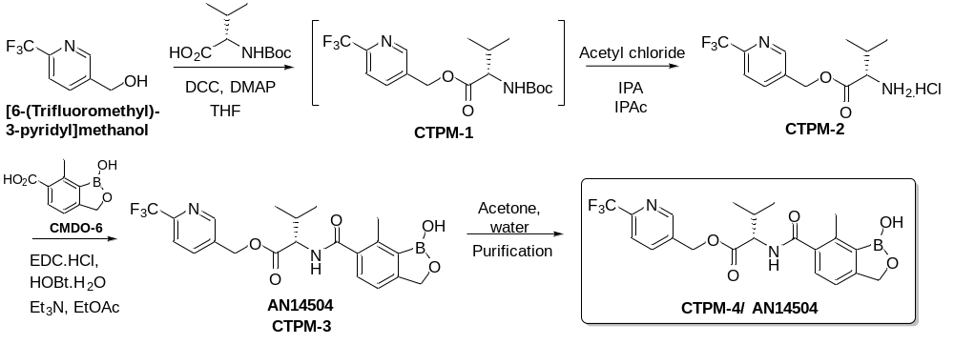

Synthetic scheme of side chain (CMDO6):

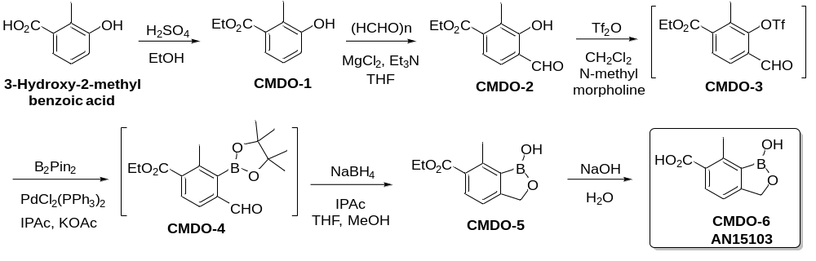

Synthetic scheme of CTPM3:
The CTPM3 process involves the coupling of 1-hydroxy-7-methyl-1,3-dihydrobenzo[c][1,2]oxaborole-6-carboxylic acid (CMDO6) with (6-(trifluoromethyl)pyridin-3-yl)methyl L-valinate hydrochloride (CTPM2) in the presence of 1-ethyl-3-[3-dimethylaminopropyl]carbodiimide hydrochloride (EDC.HCl) and a catalytic amount of hydroxybenzotriazole monohydrate (HOBt.H₂O) to provide the CTPM3 intermediate.

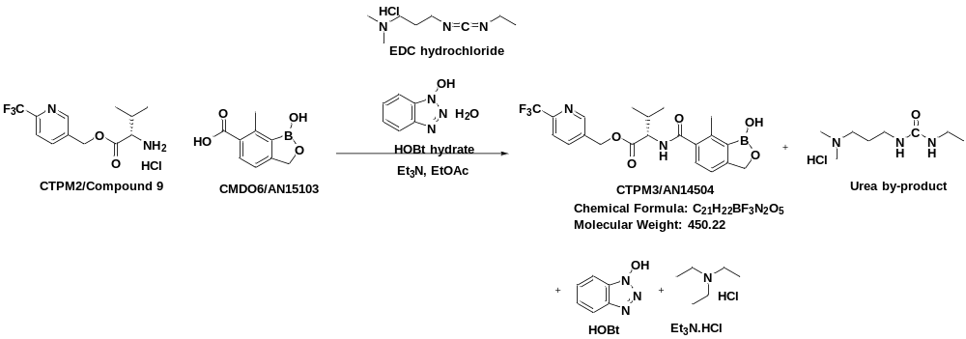

CTPM3 intermediate specifications:
S. No | Test | Specification | Remarks
1. | Apperance | White to off-white powder | -
2 | Identification test by HPLC | The retention time of the major peak in the test sample chromatogram preparation-1 should not vary more than ± 0.5 min  from the retention time of the CTPM3 peak in the system suitability solution chromatogram in the related  substances by HPLC method | -
3 | Related substances by HPLC (% w/w)  i) Impurity at about 0.21RRT (HOBt)  ii) Impurity at about 0.35RRT (CTPM2)  iii) Impurity at about 0.33 RRT (CMDO6)  iv) Impurity at about 0.47 RRT (Imp-4)  v) Impurity at about 0.53 RRT (Imp-3)  vi) Impurity at about 0.59 RRT (Imp-6)  vii) Impurity at about 0.67 RRT (Imp-7)  viii) Impurity at about 0.74 RRT (Imp-8)  ix) Impurity at about 0.80 RRT (Imp-9)  x) Impurity at about 0.86 RRT (Imp-10)  xi) Impurity at about 1.10 RRT (Imp-12a)  xii) Impurity at about 1.12 RRT (Imp-17)  xiii) Impurity at about 1.20 RRT (Imp-12b)  xiv) #Individual unspecified impurity  xv) Total Impurities | NMT 0.50  NMT 0.50  NMT 0.50  NMT 0.50  NMT 0.50  NMT 0.50  NMT 0.50  NMT 0.50  NMT 0.50  NMT 0.80  NMT 0.50  NMT 0.50  NMT 0.50  NMT 0.50  (Report more than 0.10)  Not more than 4.0 | -

List of in process controls at CTPM3 step:
IPC No | Analytical test. As per Spec. | Specification | Remarks
CTPM3-01 | Ethyl acetate water content by KF (% w/v) | NMT 0.50
CTPM3-01a | Methanol content in ethyl acetate by GC (ppm) | NMT 100
CTPM3-02 | CMDO6 content by HPLC (% area) | NMT 3.0
CTPM3-03 | Related substances by HPLC (% w/w)  i) Impurity at about 0.21RRT (HOBt)  ii) Impurity at about 0.35RRT (CTPM2)  iii) Impurity at about 0.33 RRT (CMDO6)  iv) Impurity at about 0.47 RRT (Imp-4)  v) Impurity at about 0.53 RRT (Imp-3)  vi) Impurity at about 0.59 RRT (Imp-6)  vii) Impurity at about 0.67 RRT (Imp-7)  viii) Impurity at about 0.74 RRT (Imp-8)  ix) Impurity at about 0.80 RRT (Imp-9)  x) Impurity at about 0.86 RRT (Imp-10)  xi) Impurity at about 1.10 RRT (Imp-12a)  xii) Impurity at about 1.12 RRT (Imp-17)  xiii) Impurity at about 1.20 RRT (Imp-12b)  xiv) #Individual unspecified impurity  xv) Total Impurities | NMT 0.50  NMT 0.50  NMT 0.50  NMT 0.50  NMT 0.50  NMT 0.50  NMT: 0.45  NMT 0.50  NMT 0.50  NMT 0.70  NMT 0.50  NMT 0.50  NMT 0.50  NMT 0.50  (Report more than 0.10)  Not more than 4.0
CTPM3-04 | LOD by HMA (% w/w) | NMT 2.0

List of impurities at CTPM3 step:
The known impurities observed in the CTPM3 stage are listed below:.
S. No. | IUPAC name / Internal code | Structure | RRT | Source of impurity
 | 1-Hydroxybenzotriazole / HOBt | 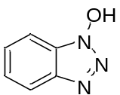 | ~0.21 | Reagent
 | (6-(Trifluoromethyl)pyridin-3-yl)  methyl L-valinate hydrochloride/CTPM2 | 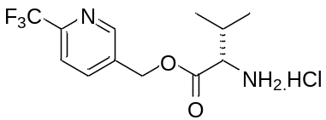 | ~0.35 | Unreacted starting material in the CTPM3 reaction.
 | 1-Hydroxy-7-methyl-1,3-dihydrobenzo[c]  [1,2]oxaborole-6-carboxylic acid/CMDO6 | 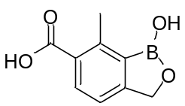 | ~0.33 | Unreacted starting material in the CTPM3 reaction.
 | (6-(Fluoromethyl)pyridin-3-yl)methyl (1-hydroxy-7-methyl-1,3-dihydrobenzo[c][1,2]oxaborole-6-carbonyl)-L-valinate/ Impurity-3 | 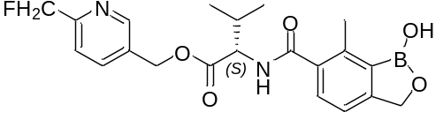 | ~0.53 | Process impurity carry over from starting material.
 | Methyl (1-hydroxy-7-methyl-1,3-dihydrobenzo[c][1,2]oxaborole-6-carbonyl)-L-valinate/Impurity-4 | 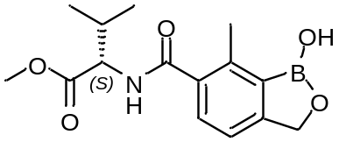 | ~0.47 | Process impurity which forms during CTPM3 reaction
 | (6-(Trifluoromethyl)pyridin-3-yl)methyl  acetyl-L-valinate/ Impurity-6 | 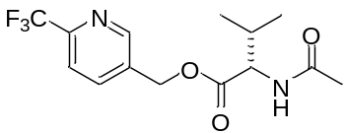 | ~0.59 | Carry over impurity from CTPM2
 | (6-(Difluoromethyl)pyridin-3-yl)methyl (1-hydroxy-7-methyl-1,3-dihydrobenzo[c][1,2]oxaborole-6-carbonyl)-L-valinate/ Impurity-8 | 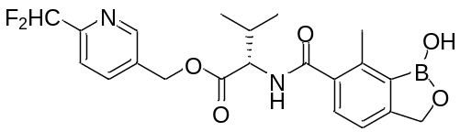 | ~0.74 | Process impurity carry over from starting material.
 | (6-(Trifluoromethyl)pyridin-3-yl)methyl (3-hydroxy-4  -(hydroxymethyl)-2-methylbenzoyl)-L-valinate/Impurity-9 | 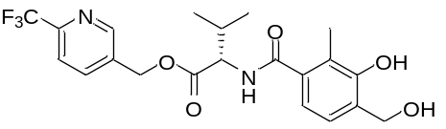 | ~0.80 | Process impurity which forms during CTPM3 reaction
 | (6-(Trifluoromethyl)pyridin-3-yl)methyl (4  -(hydroxymethyl)-2-methylbenzoyl)-L-valinate/Impurity-10 | 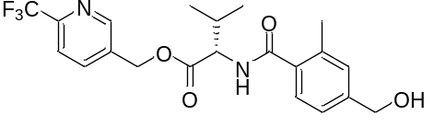 | ~0.86 | Process impurity which forms during CTPM3 reaction
 | (6-(Trifluoromethyl)pyridin-3-yl)methyl (1-hydroxy-  7-methyl-1,3-dihydrobenzo[c][1,2]  oxaborole-6-carbonyl)-L-valyl-L-valinate /Impurity-12a | 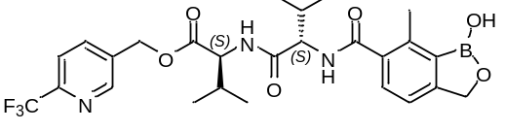 | ~1.10 | Process impurity which forms during CTPM3 reaction
 | (6-(Trifluoromethyl)pyridin-3-yl)methyl (1-hydroxy-7-methyl-1,3-dihydrobenzo[c] [1,2]oxaborole-6-carbonyl)-D-valyl-L-valinate/Impurity-12b | 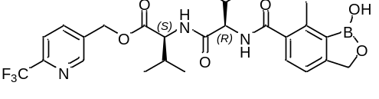 | ~1.20 | Process impurity which forms during CTPM3 reaction
 | (S)-(6-(((1H-benzo[d][1,2,3]triazol-1-yl)oxy)methyl)-2-methyl-3-((3-methyl-1-oxo-1-((6-(trifluoromethyl)pyridin-3-yl)methoxy)butan-2-yl)carbamoyl)phenyl)boronic acid/Impurity-17 | 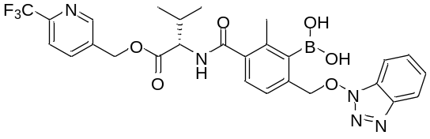 | ~1.12 | Process impurity which forms during CTPM3 reaction
 | (S)-N-(1-(cyclohexylamino)-3-methyl-1-oxobutan-2-yl)-1-hydroxy-7-methyl-1,3-dihydrobenzo[c][1,2]oxaborole-6-carboxamide/ Impurity 7 | 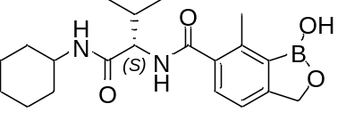 | ~0.67 | Process impurity which forms during CTPM3 reaction (Originates from 0.93 RRT impurity in CTPM2)

Impurity synthesis procedure:

1-Hydroxybenzotriazole monohydrate/ HOBt.H₂O:
Laboratory grade was procured with purity >98%.

(6-(Trifluoromethyl)pyridin-3-yl)methyl L-valinate hydrochloride/CTPM2:
CTPM2 intermediate synthesized as per finalized process (Ref document: RP-CDM-000737) and submitted as analytical standard.
Ref. B. No.: CTPM2-NB1-53 (Purity: >99%)

1-Hydroxy-7-methyl-1,3-dihydrobenzo[c] [1,2]oxaborole-6-carboxylic acid/CMDO6:
CMDO6 intermediate synthesized as per finalized process (Ref document: RP-CDM-000926) and submitted as analytical standard.
Ref. B. No.: CTPM/CMDO6-NB1-23 (Purity: 99.66%).

(6-(Fluoromethyl)pyridin-3-yl)methyl (1-hydroxy-7-methyl-1,3-dihydrobenzo[c][1,2]oxaborole-6-carbonyl)-L-valinate/ Impurity-3:
Synthetic scheme:
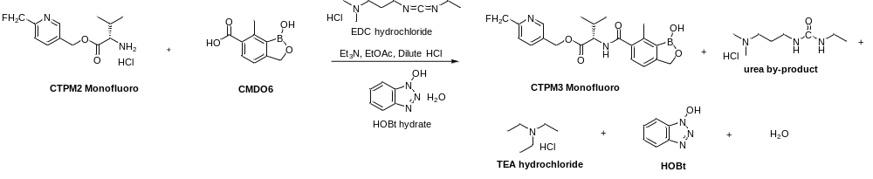
Process description:
To a cooled suspension of CMDO6 (5.0 g, 26.0 mmol), CTPM2 Monofluoro analogue (7.51 g, 31.3 mmol), EDC.HCl (6.49 g, 33.9 mmol) and HOBt monohydrate (1.994 g, 13.02 mmol) in ethyl acetate (145 mL, 29 vol) was slowly added triethylamine (7.91 g, 78 mmol) at -10 to 5 ˚C and ethyl acetate (5.0 ml) was used to rinse the triethylamine into the reaction mixture. The resulting heterogeneous reaction mixture was warmed to 15 to 25 ˚C and stirred for 18 to 24 hr. Reaction progress was monitored by TLC (5 % methanol in dichloromethane).

Workup:
5% Aqueous NaHCO₃ solution (50 mL) was added to the reaction mass and stirred for 10-15 min. The layers were separated, and the organic layer was further washed with 5% aqueous NaHCO₃ solution (50 mL). The obtained organic layer was washed twice with 1N HCl (2x 50 mL) and water (50 mL). The organic layer was then separated, evaporated and the residue codistilled with n-heptane (50 mL) under vacuum to afford a crude solid. The crude material was purified by silica gel column chromatography using a gradient elution of methanol and dichloromethane mixture of 0 to 10%. The obtained pure fractions were combined and evaporated under a vacuum to afford a solid residue (5.1 g). Dichloromethane (25 mL) was added, the mixture cooled to 10-15 ˚C, and then hexanes (50 mL) were added dropwise followed by stirring for 1-2 hr at 10-15 ˚C. The solid product was isolated by filtration, washed with hexanes (30 mL) and the wet solid was dried under vacuum at 45 ˚C to constant weight (3.85g, yield: 35.68%).
Experimental data:
S. No | Batch No | Batch size (g) | Output  (g) | Yield  (%) | Purity by HPLC (%) | Remarks
1 | CTPM/CTPM3-NB2-28 | 5.0 | 3.85 | 35.68 | 97.4 | ¹H NMR and mass spectroscopy data for the isolated product are consistent with the CTPM3 Monofluoro analogue

¹H-NMR spectrum (Impurity-3): Enclosed annexure-1
HPLC Report (Impurity-3) : Enclosed annexure-2
Mass spectrum (Impurity-3) : Enclosed annexure-19

Methyl (1-hydroxy-7-methyl-1,3-dihydrobenzo[c][1,2]oxaborole-6-carbonyl)-L-valinate/Impurity-4:
Synthetic scheme:
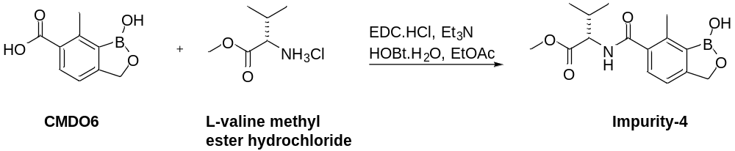
Process description:
To a suspension of CMDO6 (5.0 g, 26.0 mmol), L-valine methyl ester hydrochloride (5.68 g, 33.9 mmol), EDC.HCl (6.47 g, 33.9 mmol) and HOBt.H₂O (3.99 g, 26.0 mmol) in ethyl acetate (145 ml, 29 vol), was slowly added triethylamine (10.54 g, 104 mmol) at -5 to 10 ºC and the addition vessel rinsed with ethyl acetate (5 ml, 1 vol.). The reaction mixture was warmed to 25-30 ºC and stirred overnight under a nitrogen atmosphere. Reaction progress was monitored by HPLC, and the CMDO6 content was observed to be below 0.50%.
Workup:
The reaction mass was washed thrice with 5% sodium bicarbonate (3x 50 ml, 3x 10 vol) followed by thrice with 1M HCl (3 x 50 ml, 3 x10 vol) and finally with water (50 ml, 10 vol). The organic layer was concentrated to dryness under a vacuum below 50 °C to afford an off-white color solid.
Experimental data:
S. No | Batch No | Batch size (g) | Output (g) | Yield  (%) | Purity by HPLC (%) | Remarks
1 | CTPM/CTPM3-NB1-47 | 5.0 | 4.0 | 50.31 | 91.3 | ¹H NMR, mass spectroscopy and HPLC data for the isolated product are consistent with Impurity-4
¹H-NMR spectrum (Impurity-4): Enclosed annexure-3
HPLC Report (Impurity-4) : Enclosed annexure-4
Mass Spectrum (Impurity-4) : Enclosed annexure-20

(6-(Trifluoromethyl)pyridin-3-yl)methyl acetyl-L-valinate/ Impurity-6:
Synthetic scheme:
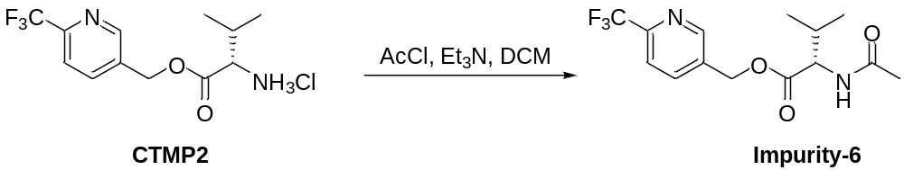
Process description:
To a suspension of CTPM2 (7.0 g, 22.38 mmol) and triethylamine (9.06 g, 90 mmol) in dichloromethane (90 mL) was slowly added acetyl chloride (2.64 g, 33.6 mmol) at 0-10 ºC and the reaction mixture stirred for 1-2hr. Reaction progress was monitored by TLC, and the absence of starting material was observed.

Workup:
Water (70mL, 10vol) was added into the reaction mixture at 0-10 ºC, the mixture was stirred for 5-10 min and the organic layer separated. The organic layer was washed with 1N HCl (70 ml, 10 vol) and 5% aqueous sodium bicarbonate (70 ml, 10 vol). The organic layer was then concentrated to dryness to afford Impurity-6 as a viscous liquid which solidified after 1-2 days at 2-8 ºC.
Experimental data:
S. No | Batch No | Batch size (g) | Output (g) | Yield  (%) | Purity by HPLC (%) | Remarks
1 | CTPM/CTPM2-NB1-52 | 7.0 | 8.0 | Quant. | 98.4 | ¹H NMR, mass spectroscopy and HPLC data for the isolated product are consistent with Impurity-6.
¹H-NMR spectrum (Impurity-6): Enclosed annexure-5
HPLC Report (Impurity-6): Enclosed annexure-6
Mass Spectrum (Impurity-6): Enclosed annexure-21

(6-(Difluoromethyl)pyridin-3-yl)methyl (1-hydroxy-7-methyl-1,3-dihydrobenzo[c][1,2]oxaborole-6-carbonyl)-L-valinate/ Impurity-8:
Synthetic scheme:

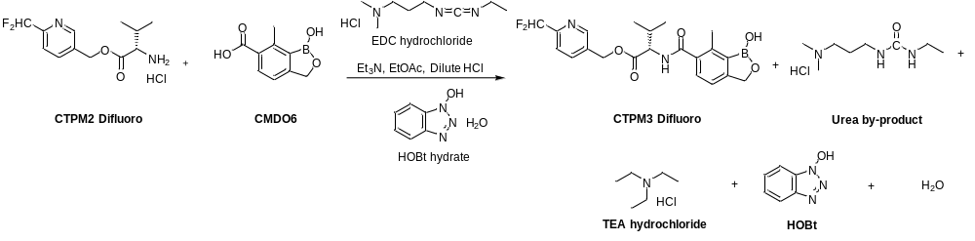
Process description:
To a cooled suspension of CMDO6 (2.7 g, 14.06 mmol), CTPM2 Difluoro analogue (4.0 g, 15.47 mmol), EDC.HCl (2.97 g, 15.47 mmol) and HOBt monohydrate (1.077 g, 7.03 mmol) in ethyl acetate (78.3 mL, 29 vol) was slowly added triethylamine (4.27 g, 42.2 mmol) at -10 to 5 ˚C and ethyl acetate (2.7ml) was used to rinse the triethylamine into the reaction mixture. The resulting heterogeneous reaction mixture was warmed to 15 to 25 ˚C and stirred for 18 to 24 hr. Reaction progress was monitored by TLC (5 % methanol in dichloromethane).
Workup:
To the reaction mass was added 5% NaHCO₃ Lot-1 (27 mL) and after stirring for 10-15 min, the layers were separated, and the organic layer was further washed with 5% NaHCO₃ Lot-2 (27 mL). The organic layer was then separated and washed firstly with 1N HCl (2x 27 mL) and then with water (27 mL). The organic layer was distilled to 2-3 volumes and codistilled with n-heptane (27 mL) and finally the solid was dried under vacuum to constant weight.
5% Aqueous NaHCO₃ solution (27 mL) was added to the reaction mass and stirred for 10-15 min, the layers were separated, and the organic layer further washed with 5% aqueous NaHCO₃ solution (27 mL). The obtained organic layer was washed twice with 1N HCl (2x 27 mL) and water (27 mL). Following separation, the organic layer was evaporated, and codistilled with n-heptane (27 mL) under vacuum to afford crude solid (4.8 g, yield: 79.08%).
Experimental data:
S. No | Batch No | Batch size (g) | Output (g) | Yield  (%) | Purity by HPLC (%) | Remarks
1 | CTPM/CTPM3-NB2-25 | 2.7 | 4.8 | 79.08 | 97.3 | 1H NMR and mass spectroscopy data for the isolated product are consistent with Impurity-8 (CTPM3 Difluoro analogue)
¹H-NMR spectra (Impurity-8) : Enclosed annexure-7
HPLC Report (Impurity-8) : Enclosed annexure-8
Mass Spectrum (Impurity-8): Enclosed annexure-22

(6-(Trifluoromethyl)pyridin-3-yl)methyl (3-hydroxy-4-(hydroxymethyl)-2-methylbenzoyl)-L-valinate/Impurity-9:
Synthetic scheme:

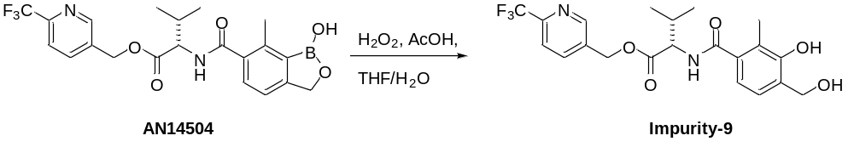
Process description:
To a solution of AN14504 (4.0 g, 8.88 mmol) in THF (20 ml, 5 vol) was added water (20 ml) dropwise over 5 minutes followed by acetic acid (20 ml, 5 vol) over 5 minutes. To the resulting white suspension was dropwise added 35% hydrogen peroxide (0.302 ml, 8.88 mmol) and THF (10 ml, 2.5 vol). The reaction mass was stirred at 25-35 °C for 43h and reaction progress was monitored by HPLC, showing >37.2% of AN14504 and 57.9 % of Impurity 9. The second lot of 35% hydrogen peroxide (0.151 mL, 4.44 mmol) was added and the reaction mixture was stirred for 24hr at 25-35 °C. 8.6% of AN14504 and 86.0 % of Impurity 9 were observed in the reaction mass. An additional lot of 35% hydrogen peroxide (0.151 mL, 4.44 mmol) was then added to the reaction mixture and stirred at 25-35 °C for 5h. Finally, 2.47 % of AN14504 remained with 91.71% of Impurity-9 in the reaction mass.

Workup:
The reaction mixture was cooled to 0-5 °C and the pH of the reaction mass adjusted to 8-9 using saturated aqueous sodium thiosulfate (~150 mL). The layers were separated, and the aqueous layer was extracted with ethyl acetate (2 x 60 mL). The combined organic extracts were washed with water (40 mL) and evaporated to dryness at 45 °C to afford a clear pale-yellow oil which solidified upon drying under a vacuum.

Experimental data:
S. No | Batch No | Batch size (g) | Output (g) | Yield  (%) | Purity by HPLC (%) | Remarks
1 | CTPM/CTPM3-NB1-43 | 4.0 | 3.6 | 92.7 | 94.82 | 1H NMR and mass spectroscopy data for the isolated product are consistent with Impurity-9
¹H-NMR spectrum (Impurity-9): Enclosed annexure-9
HPLC Report (Impurity-9) : Enclosed annexure-10
Mass Spectrum (Impurity-9): Enclosed annexure-23

(6-(Trifluoromethyl)pyridin-3-yl)methyl (4-(hydroxymethyl)-2-methylbenzoyl)-L-valinate/Impurity-10:
Synthetic scheme:
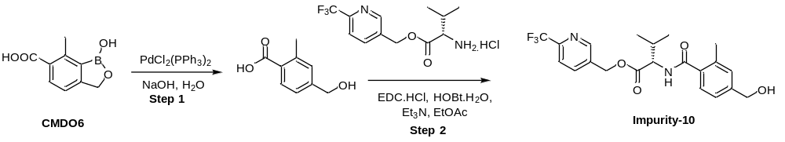

Process description:
Step-1:
To a solution of sodium hydroxide (4.95 g, 124 mmol) in water (80 ml) was added CMDO6 (9.5 g, 49.5 mmol) and PdCl₂(PPh₃)₂ (0.347 g, 0.495 mmol, 0.01 eq). The resulting yellow mixture was stirred at 40 - 45 ºC for 40hr and the absence of starting material was confirmed by HPLC.
Work up (Step-1):
The reaction was filtered through Celite, and the filter cake was washed with water (80 mL, 8 vol) to give a clear orange solution. The aqueous filtrate and wash were extracted twice with ethyl acetate (2 x 100 mL). 1N HCl (50 ml) was added slowly to the aqueous layer over 10 minutes, and then the precipitated solid was filtered and washed with water (50 mL). The wet cake was suction dried to afford 4-(hydroxymethyl)-2-methylbenzoic acid (4.6 g, 56% yield) as a pale-yellow solid. This solid was used as such in Step-2 without any further purification.
Step-2:
To a suspension of CTPM2 (7.98 g, 28.9 mmol), Step-1 intermediate (4.0 g, 24.07 mmol), EDC.HCl (5.54 g, 28.9 mmol) and HOBt.H₂O (4.42 g, 28.9 mmol) in ethyl acetate (108 ml, 27 vol) was slowly added triethylamine (9.74 g, 96 mmol) at 0-5 ºC and the addition funnel rinsed with ethyl acetate (4 ml, 1 vol.). The mixture was allowed to warm to 25-35 ºC and stirred for 18-24 hr. Reaction progress was monitored by HPLC.
Work up (Step-2):
The reaction mass was washed thrice with 5% aq. sodium bicarbonate (3x 40 ml), followed by thrice with 1M HCl (3x 40 ml). The organic layer was concentrated to dryness under a vacuum below 50 °C to afford 7.9g of an off-white solid.
Purification: The solid obtained following work up was stirred in 50 mL of 20% ethyl acetate-hexanes mixture for 1-2 h. The solid was filtered and washed with a 20% ethyl acetate-hexane mixture (25 mL). This procedure was repeated once again to afford 6.55 g of Impurity-10 (Yield: 64.09%, purity: 91.96%).
Experimental data:
S. No | Batch No | Batch size (g) | Output (g) | Yield  (%) | Purity by HPLC (%) | Remarks
1 | CTPM/CTPM3-NB1-69 | 4.0 | 6.55 | 64.09 | 91.96 | ¹H NMR and mass spectroscopy data for the isolated product are consistent with Impurity-10
¹H-NMR spectra (Impurity-10): Enclosed annexure-11
HPLC Report (Impurity-10) : Enclosed annexure-12
Mass Spectrum (Impurity-10): Enclosed annexure-24

(6-(Trifluoromethyl)pyridin-3-yl)methyl (1-hydroxy-7-methyl-1,3-dihydrobenzo[c][1,2]oxaborole-6-carbonyl)-L-valyl-L-valinate /Impurity-12a:
Synthetic scheme:

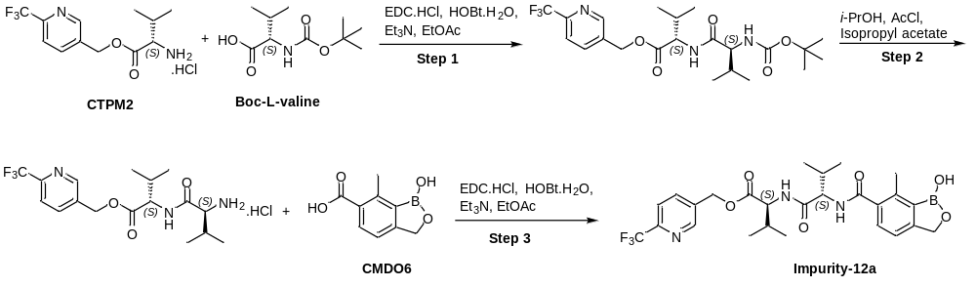

Process description:
Step-1:
To a suspension of CTPM2 (5.0 g, 15.99 mmol), EDC.HCl (4.71 g, 24.62 mmol), HOBt.H₂O (3.77 g, 24.62 mmol) and Boc-L-valine (4.86 g, 22.38 mmol) in ethyl acetate (145 ml, 29 vol) was slowly added triethylamine (6.96 g, 68.8 mmol) at -5˚C to 10˚C. The reaction mixture was warmed to 15 to 25 ˚C and stirred for 18-24 hr. Reaction progress was monitored by TLC (50% ethyl acetate: hexane).
Work up:
The reaction mass was washed thrice with 5% aq. sodium bicarbonate (3 x 50 ml) followed by washing thrice with 1M HCl (3 x 50 ml). The organic layer was concentrated to 4-5 volumes and used as such in Step-2.
Step-2:
The solution of Step 1 product in ethyl acetate was evaporated under vacuum, and the residue was diluted with 50 ml of isopropyl acetate. In another round bottom flask-2 was charged isopropyl acetate (77.5 mL) and isopropanol (12.55 mL, 160 mmol), and the mixture then cooled to -5 to 10 ˚C. To the cooled mixture was added dropwise acetyl chloride (11.53g, 192 mmol) and the reaction mixture was maintained at -5° to 10°C for 30-60 min. The solution of step-1 product in isopropyl acetate (as obtained above) was added dropwise at -5 to 10 ˚C into flask-2 and the reaction mass was then warmed to 25-35 ˚C and stirred for 18-24 h. Completion of the reaction was confirmed by TLC. The solid suspension was filtered under nitrogen and washed with isopropyl acetate (3 x 20 mL). The wet solid product was dried under a vacuum below 45 °C to afford 5.1 g of the Step-2 product.

Step-3:
To a suspension of CDMO6 (1.5 g, 8.0 mmol), Step-2 intermediate (4.5 g, 11.0 mmol), EDC.HCl (2.3 g, 12 mmol) and HOBt.H₂O (1.84 g, 12.0 mmol) in ethyl acetate (45.0 ml, 30 vol) was slowly added triethyl amine (3.4 g, 34 mmol) at -5 ˚C to 10 ˚C. The reaction mixture was warmed to 15 to 25 ˚C and stirred for 18-24 hr. Reaction progress was monitored by TLC (5% MeOH/DCM), showing complete conversion of starting material.
Work up:
The reaction mass was washed three times with 5% aq. sodium bicarbonate (3 x 50 ml) followed by thrice with 1M HCl (3 x 50 ml). The organic layer was separated and concentrated under a vacuum to afford a solid product.
Experimental data:
S. No | Batch No | Batch size (g) | Output (g) | Yield  (%) | Purity by HPLC (%) | Remarks
1 | CTPM/CTPM3-NB1-30  (Impurity-12a) | 5.0 | 2.7 | 31.5 (overall  3-step) | 95.18 | ¹H NMR, mass spectroscopy and HPLC data for the isolated product are consistent with Impurity-12a.
¹H-NMR spectrum (Impurity-12a): Enclosed annexure-13
HPLC Report (Impurity-12a) : Enclosed annexure-14
Mass Spectrum (Impurity-12a): Enclosed annexure-25

(6-(Trifluoromethyl)pyridin-3-yl)methyl (1-hydroxy-7-methyl-1,3-dihydrobenzo[c] [1,2]oxaborole-6-carbonyl)-D-valyl-L-valinate/Impurity-12b:
Synthetic scheme:

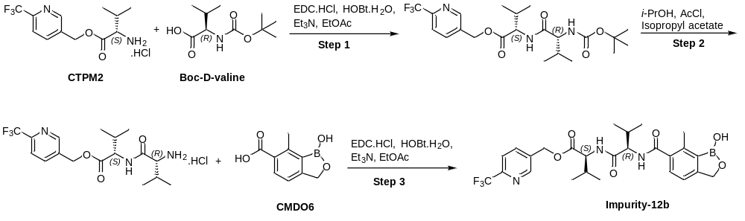

Process description:
Step-1:
To a suspension of CTPM2 (5.0 g, 15.99 mmol), EDC.HCl (4.71 g, 24.62 mmol), HOBt.H₂O (3.77 g, 24.62 mmol) and Boc-D-valine (4.86 g, 22.38 mmol) in ethyl acetate (145 ml, 29 vol) was slowly added triethylamine (6.96 g, 68.8 mmol) at -5˚C to 10˚C. The reaction mixture was warmed to 15 to 25 ˚C and stirred for 18-24 hr. Reaction progress was monitored by TLC (50% ethyl acetate: hexane), showing complete conversion of starting material.
Work up:
The reaction mass was washed thrice with 5% aq. sodium bicarbonate (3 x 50 ml) followed by washing thrice with 1M HCl (3 x 50 ml). The organic layer was concentrated to 4-5 volumes and used as such in Step-2.
Step-2:
The solution of Step 1 product in ethyl acetate was evaporated under a vacuum and the residue was diluted with 50 ml of isopropyl acetate. In another round bottom flask was charged isopropyl acetate (77.5 mL), isopropanol (12.55 mL, 160 mmol), and the mixture cooled to -5 to 10 ˚C. To the cooled mixture was added dropwise acetyl chloride (11.53g, 192 mmol) and the reaction mixture was maintained at -5° to 10°C for 30-60 min. The solution of Step-1 product in isopropyl acetate (as obtained above) was added dropwise at -5 to 10 ˚C and the reaction mass warmed to 25-35 ˚C and stirred for 18-24 h. Completion of the reaction was confirmed by TLC. The solid suspension was filtered under nitrogen and washed with isopropyl acetate (3 x 20 mL). The obtained wet solid was dried under vacuum below 45 °C to afford 3.8 g of the Step-2 product.

Step-3:
To a suspension of CDMO6 (1.25 g, 6.5 mmol), Step-2 intermediate (2.94 g, 7.1 mmol), EDC.HCl (1.9 g, 10.0 mmol), and HOBt.H₂O (1.53 g, 10.0 mmol) in ethyl acetate (37.5 ml, 30 vol) was slowly added triethylamine (2.83 g, 28 mmol) at -5 ˚C to 10 ˚C. The reaction mixture was warmed to 15 to 25 ˚C and stirred for 18-24 hr. Reaction progress was monitored by TLC (5% MeOH/DCM), showing complete conversion of starting material.
Work up:
The reaction mass was washed three times with 5% aq. sodium bicarbonate (3 x 50 ml) followed by washing thrice with 1M HCl (3 x 50 ml). The organic layer was concentrated to dryness under vacuum to afford the solid product.
Experimental data:
S. No | Batch No | Batch size (g) | Output (g) | Yield  (%) | Purity by HPLC (%) | Remarks
1 | CTPM3-NB1-34  (Impurity-12b) | 5.0 | 2.5 | 29.2 (overall  3-steps) | 91.34 | ¹H NMR, mass spectroscopy and HPLC data for the isolated product are consistent with Impurity-12b

¹H-NMR spectrum (Impurity-12b): Enclosed annexure-15
HPLC Report (Impurity-12b) : Enclosed annexure-16
Mass Spectrum (Impurity-12b): Enclosed annexure-26

(S)-(6-(((1H-benzo[d][1,2,3]triazol-1-yl)oxy)methyl)-2-methyl-3-((3-methyl-1-oxo-1-((6-(trifluoromethyl)pyridin-3-yl)methoxy)butan-2-yl)carbamoyl)phenyl)boronic acid/Impurity-17:
Impurity-17 was synthesized at Almac Sciences Ltd, and 3.0 g of this impurity was received with purity 92.4%

(S)-N-(1-(cyclohexylamino)-3-methyl-1-oxobutan-2-yl)-1-hydroxy-7-methyl-1,3-dihydrobenzo[c][1,2]oxaborole-6-carboxamide/Impurity-7:
Synthetic scheme:
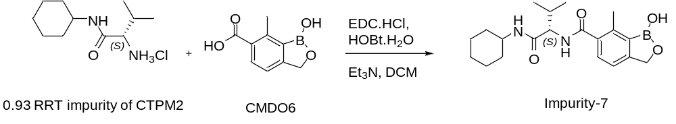

Process description:
To a cooled solution of the 0.93 RRT impurity of CTPM2 (10.0 g, 42.6 mmol), EDC.HCl (8.98 g, 46.9 mmol) and HOBt.H₂O (7.18 g, 46.9 mmol) in DCM (100 mL, 10 vol) at 10 to 20 ˚C was added triethylamine (12.93 g, 128 mmol) dropwise. The resultant reaction mixture was warmed to 20 to 30 ˚C and stirred for 18-24 hrs. Reaction progress was monitored by TLC (5% Methanol: DCM).

Workup:
The heterogeneous reaction mass was filtered and the solids washed with DCM (100 mL, 10 vol), the obtained solid was then transferred into a clean RBF. THF (200mL 20 vol) was charged to the flask, and the resulting heterogenous mass was warmed to 40 to 50 ˚C to obtain a homogenous solution. Treated water (400 mL, 40 vol) was then added dropwise to the above homogenous solution at 40 to 50 ˚C, after complete addition the mixture was gradually cooled to 10 to 20 ˚C and stirred for 1-2 h. The obtained solid was filtered and the wet cake washed with treated water (100 mL, 10 vol) and finally washed with n-hexane (2X 50 mL). The wet cake was then suction dried for 15 to 30 min, and the obtained wet material was dried under vacuum at 40 to 50 ˚C to obtain constant weight (Wt.: 7.16 g, 45 %).

Experimental data:
S. No | Batch No | Batch size (g) | Output (g) | Yield  (%) | Purity by HPLC (%) | Remarks
1 | CTPM3-NB3-08 | 10 | 7.16 | 45 | 98.53 | ¹H NMR and mass spectroscopy data for the isolated product are consistent with Impurity-7 of CTPM3.

¹H-NMR spectrum (Impurity-7): Enclosed annexure-17
HPLC Report (Impurity-7) : Enclosed annexure-18
Mass Spectrum (Impurity-7): Enclosed annexure-27

CTPM3 purging studies:

Purging study of CTPM3 impurities (>0.50%) during ethyl acetate-heptane crystallization
Initial studies. After completion of the CTPM3 reaction, the wet cake obtained following crystallization was analysed for impurities including Impurity-4, Impurity-6, Impurity-9, Impurity-10, Impurity-12a, Impurity-12b and Impurity-17 content with a limit of NMT 0.50% for individual impurities. To assess the ability of ethyl acetate-heptane purification to purge all the above impurities, these seven impurities were spiked >0.50% (area) in CTPM3 and the ethyl acetate and n-heptane purification was carried out as per the optimized process. Experimental details are tabulated below.
Batch No. | Input (g) | Yield  (%) | Purity by HPLC (%area) |  |  |  |  |  |  |  |  |  |  | Remarks
Batch No. | Input (g) | Yield  (%) | CMDO6 | CTPM3 | CTPM2 | IMP-6 | IMP-7 | IMP-4 | IMP-9 | IMP-10 | IMP-12a | IMP-17 | IMP-12b | Remarks
CTPM/CTPM3-NB2-15 | 5.0 | N/A | 0.03 | 93.04 | ND | 0.99 | 0.16 | 0.72 | 0.56 | 1.05 | 0.83 | 0.71 | 1.24 | Crude CTPM3 after spiking impurity
CTPM/CTPM3-NB2-15 | 5.0 | 80.0 | 0.01 | 94.60 | ND | 0.28 | 0.11 | 0.46 | 0.67 | 1.16 | 0.65 | 0.51 | 1.02 | Purity after 1st crystallization  Output: 4.1 g
CTPM/CTPM3-NB2-15 | 5.0 | 75.0 | ND | 98.26 | ND | ND | 0.03 | 0.40 | 0.33 | 0.29 | 0.10 | 0.09 | 0.14 | Purity after 2nd crystallization  Output: 3.6 g
IMP-impurity, ND: Not detected

Conclusion: Based on the above experimental details, it is concluded that the purification process is capable of purging most of the listed impurities at the levels initially studied to below the specified limit of NMT 0.50% area by HPLC, noting that Impurity 4 is not purged to a low level. It was noted however that a small increase in levels of Impurity 9 and Impurity 10 was seen after the first purification. The probable reason for this was a slight variation in the first crystallization operation with respect to the standard conditions. As per the regular process, CTPM3 is dissolved in ethyl acetate (~30 volumes) and distilled up to 10-12 volumes, and then n-heptane is added slowly to crystallize the CTPM3. However, in the above experiment, 12 volumes of ethyl acetate were added directly to the crude CTPM3 after spiking the impurities, followed by 30 volumes of n-heptane. The crystallization in this experiment was effectively a slurry purification method as opposed to a crystallization as performed in the usual process, and this resulted in higher levels of Impurity-9 and Impurity-10 after the first crystallization. A second crystallization (of the product of the first crystallization) was then conducted according to the standard conditions, and it was shown that in those cases where impurity levels are higher than 0.50% after the first purification, a second purification operation was effective in reducing levels to within specification.

Follow-up study: In view of the observation regarding recrystallisation conditions in the initial study, the above experiment was repeated to determine the level of purging of Impurity-9 and Impurity-10 under the standard ethyl acetate and n-heptane crystallization. The input CTPM3 contained different levels of spiked impurities with respect to the initial study, and the results are tabulated below.

Batch No. | Input (g) | Yield  (%) | Purity by HPLC (%area) |  |  |  |  |  |  |  |  |  |  | Remarks
Batch No. | Input (g) | Yield  (%) | CMDO6 | CTPM3 | CTPM2 | IMP-6 | IMP-7 | IMP-4 | IMP-9 | IMP-10 | IMP-12a | IMP-17 | IMP-12b | Remarks
CTPM/CTPM3-NB2-32 | 5.0 | 75.85 | 0.015 | 95.01 | ND | 0.67 | 0.18 | 0.60 | 0.65 | 0.61 | 0.56 | 0.66 | 0.55 | Crude CTPM3 after spiking impurity
CTPM/CTPM3-NB2-32 | 5.0 | 75.85 | ND | 97.78 | ND | 0.04 | 0.06 | 0.47 | 0.32 | 0.18 | 0.12 | 0.28 | 0.08 | CTPM3 dry purity after crystallization
CTPM/CTPM3-NB2-32 | 5.0 | 75.85 | 0.07 | 61.76 | ND | 4.3 | 1.2 | 1.6 | 2.96 | 4.04 | 4.58 | 4.16 | 4.59 | CTPM3 mother liquor impurity profile
IMP-impurity, ND: Not detected
Conclusion: Based on the above experimental data, the current CTPM3 purification process is capable of purging the listed impurities from spiked levels of 0.55-0.66% to below the specified limit of NMT 0.50% area by HPLC. Impurities 4, 9, 10, 12a and 17 are nevertheless not purged to a very low level as a result of this ethyl acetate-and n-heptane crystallization, remaining between 0.12 and 0.47% area in the dried recrystallized CTPM3.

Purging study of CMDO6 intermediate >1.0% in CTPM3 reaction mass:
During the conversion of CMDO6 to CTPM3, CMDO6 content is monitored in IPC (in-process control), and the limit is NMT 1.0% (% area). To assess the ability of the CTPM3 process to eliminate higher levels of CMDO6, the CTPM3 reaction mass containing CMDO6 at a level >1.0% was washed with aqueous sodium bicarbonate solution and then 1N HCl as per the finalized process. It was observed that CMDO6 levels were substantially reduced in the organic layer, with CMDO6 being washed into the aqueous sodium bicarbonate layer. Experimental details are as follows,
Batch No. | Input (g) | Purity by HPLC (%area) |  |  |  |  |  |  |  |  |  |  | Remarks
Batch No. | Input (g) | CMDO6 | CTPM3 | CTPM2 | IMP-6 (0.61RRT) | IMP-7 | IMP-4 | IMP-9 | IMP-10 | IMP-12a | IMP-17 | IMP-12b
CTPM/CTPM3-NB1-96 | 20.0 | 5.05 | 80.49 | 3.68 | 0.23 | 0.21 | 0.03 | 0.21 | 0.55 | 0.24 | 0.31 | 0.24 | Reaction mass
CTPM/CTPM3-NB1-96 | 20.0 | 32.15 | 7.55 | 0.42 | 0.20 | 0.14 | 0.05 | 0.03 | 0.04 | 0.02 | 0.02 | 0.01 | 1st NaHCO₃ aqueous layer wash
CTPM/CTPM3-NB1-96 | 20.0 | 4.00 | 44.67 | 0.86 | 2.69 | 1.86 | 0.47 | 0.12 | 0.02 | 0.06 | ND | 0.04 | 2nd NaHCO₃ aqueous layer wash
CTPM/CTPM3-NB1-96 | 20.0 | 0.70 | 95.94 | 0.07 | 0.19 | 0.21 | 0.01 | 0.21 | 0.67 | 0.29 | 0.38 | 0.30 | Organic layer after sodium bicarbonate and 1N HCl wash.

Conclusion: Based on the above experimental details, unreacted CMDO6 at levels up to ca. 5% area is reduced to <1.0% (specifically 0.70%) in the organic layer following aqueous sodium bicarbonate and 1N HCl washing.

Purging study of CTPM2 intermediate in CTPM3 reaction mass:
During the conversion of CMDO6 to CTPM3, the intermediate CTPM2 is used in excess (1.1eq) and remains in excess during the reaction. To assess the ability of the CTPM3 process to eliminate higher levels of CTPM2 in the CTPM3 step, the reaction mass containing CTPM2 at a level of 3.68% was washed twice with aqueous sodium bicarbonate solution followed by 1N aqueous HCl as per finalized process. It was observed that CTPM2 levels are substantially reduced in the organic layer following the aqueous sodium bicarbonate washes and the subsequent aqueous HCl wash. Experimental details are tabulated below.

Batch No. | Input (g) | Purity by HPLC (%area) |  |  |  |  |  |  |  |  |  |  | Remarks
Batch No. | Input (g) | CMDO6 | CTPM3 | CTPM2 | IMP-6 (0.61RRT) | IMP-7 | IMP-4 | IMP-9 | IMP-10 | IMP-12a | IMP-17 | IMP-12b | Remarks
CTPM/CTPM3-NB1-96 | 20.0 | 5.05 | 80.49 | 3.68 | 0.23 | 0.21 | 0.03 | 0.21 | 0.545 | 0.24 | 0.31 | 0.24 | Reaction mass
CTPM/CTPM3-NB1-96 | 20.0 | 32.15 | 7.55 | 0.42 | 0.20 | 0.14 | 0.05 | 0.03 | 0.04 | 0.02 | 0.02 | 0.01 | 1st NaHCO₃ aqueous layer wash
CTPM/CTPM3-NB1-96 | 20.0 | 4.00 | 44.67 | 0.86 | 2.69 | 1.86 | 0.47 | 0.124 | 0.02 | 0.06 | ND | 0.04 | 2nd NaHCO₃ aqueous layer wash
CTPM/CTPM3-NB1-96 | 20.0 | 1.39 | 1.86 | 71.07 | 0.03 | 0.03 | 0.01 | ND | 0.04 | ND | ND | ND | 1N HCl aqueous layer wash (combined)
CTPM/CTPM3-NB1-96 | 20.0 | 0.70 | 95.94 | 0.07 | 0.19 | 0.21 | 0.01 | 0.21 | 0.67 | 0.29 | 0.38 | 0.30 | Organic layer after aqueous sodium bicarbonate and 1N HCl wash
IMP-impurity, ND: Not detected
Conclusion: Based on the above experimental details, unreacted CTPM2 at levels up to 3.68% area is reduced to a very low level (0.07 % area) in the organic layer following aqueous sodium bicarbonate and 1N HCl washing. CTPM2 is substantially extracted into the acidic aqueous layer.

Spiking and purging study of Impurity-7 in CTPM3
The 0.93 RRT impurity of CTPM2 is a precursor for Impurity-7 in CTPM3. The CTPM3 experiment below was conducted with CTPM2 intermediate containing the 0.93 RRT impurity with a level of ca. 0.57% w/w by HPLC. The Impurity-7 was observed to form at a level of 1.51% in the reaction mass and was observed at 0.44% w/w in isolated CTPM3 solid after ethyl acetate and n-heptane purification, therefore at less than the specified limit of NMT: 0.50% (Impurity 7 had previously been indicated as unspecified impurity during the demonstration batches). This impurity was observed at a level of 3.93% in the mother liquors from the CTPM3 purification. Experimental details are tabulated below.
Batch No. | Input (g) | Yield  (%) | Purity by HPLC (%w/w) |  |  |  |  |  |  |  |  |  |  | Remarks
Batch No. | Input (g) | Yield  (%) | CMDO6 | CTPM3 | CTPM2 | IMP  -6 | *IMP-7 | IMP  -4 | IMP  -9 | IMP  -10 | IMP-12a | IMP  -17 | IMP-12b | Remarks
CTPM/CTPM3-NB2-92 | 2.5 | 78.5 | 0.26 | 82.34 | ND | 0.23 | 1.51 | 0.31 | 0.27 | 0.66 | 0.10 | 0.53 | 0.45 | CTPM3 reaction mass
CTPM/CTPM3-NB2-92 | 2.5 | 78.5 | ND | 97.97 | 0.01 | ND | 0.44 | 0.01 | 0.023 | 0.26 | 0.12 | 0.15 | 0.13 | CTPM3 purity after crystallization
CTPM/CTPM3-NB2-92 | 2.5 | 78.5 | 2.18 | 80.08 | 0.02 | 0.01 | 3.93 | 0.01 | 0.62 | 1.79 | 1.96 | 2.82 | 2.53 | CTPM3 mother liquor impurity profile
The experiment below was performed to check the level of purging of the above obtained 0.44%w/w impurity-7 in CTPM4 purification
CTPM/CTPM4-NB1-75 | 2.0 | 86.5 | ND | 98.77 | ND | 0.03 | 0.13 | ND | 0.11 | 0.14 | 0.05 | 0.05 | 0.06 | To check the purging of Impurity-7 in CTPM4 purification.
IMP-impurity, ND: Not detected; *Imp-7 %w/w by HPLC (considering RRF:1.0), noting that during this study RRF was not established for Impurity-7.

Conclusion: Based on the above experimental data, the current CTPM3 purification process is capable of purging the Impurity-7 from levels of 0.57% w/w in input CTPM2 with 0.93 RRT impurity to below the specified limit of NMT 0.50% area by HPLC, and in the subsequent CTPM4 recrystallisation Impurity-7 is significantly purged to the level of 0.13% from 0.44% (specified limit of NMT: 0.50%).

In continuation to the above studies, when RRF data became available for this impurity, further spiking and purging studies of Impurity-7 were conducted by spiking Impurity 7 at >1.0% w/w in CTPM3. Experimental details are tabulated below.

Expt. No. | Input  (g) | %w/w Spiked in CTPM3 | Impurity limit in CTPM3  % w/w | Remarks
CTPM3-NB3-10 | 5.0 | *1.12 | 0.50 | Aim: Spiking of Impurity-7 > 1.0 % w/w by HPLC in CTPM2.
*Imp-7 %w/w by HPLC (considering RRF:1.1)
Observation: In the above experiment the level of Impurity-7 was spiked at >1.0% w/w in CTPM3, giving 1.12% w/w in CTPM3 based on a RRF factor of 1.1. Purging studies were then conducted and the experimental details are tabulated below.

CTPM3 impurity profile:
Batch No. | Input (g) | #Yield  (%) | Purity by HPLC (%w/w) |  |  |  |  |  |  |  |  |  |  | Remarks
Batch No. | Input (g) | #Yield  (%) | CMDO6 | CTPM3 | CTPM2 | IMP-6 | IMP-7 | IMP-4 | IMP-9 | IMP-10 | IMP-12a | IMP-17 | IMP-12b | Remarks
CTPM/CTPM3-NB3-11 | 4.5 | 88.9 | ND | 98.08 | ND | ND | 0.78 | 0.46 | 0.24 | 0.04 | 0.10 | 0.02 | 0.04 | After 1st ethyl acetate/n-heptane purification (input Impurity-7 content 1.12% w/w)
CTPM/CTPM3-NB3-16 | 3.0 | 90.3 | ND | 98.49 | ND | ND | 0.55 | 0.37 | 0.17 | 0.05 | 0.05 | ND | 0.05 | After 2st ethyl acetate/n-heptane purification (input Impurity-7 content 0.78% w/w)
CTPM/CTPM3-NB3-17 | 2.5 | 88.0 | ND | 99.19 | ND | ND | 0.34 | 0.31 | 0.08 | ND | ND | ND | ND | After 3rd ethyl acetate/n-heptane purification (input Impurity-7 content 0.55 % w/w)
IMP-impurity, ND: Not detected; # % Recovery (Yield)
Conclusion: Based on the above experimental details, when Impurity 7 was spiked at a level of >1.0 % w/w in the product of the CTPM3 step, it was clearly indicated from successive ethyl acetate and n-heptane purifications, that this impurity has minimal purgeability (around 20-30%). Given that each purification is accompanied by a significant amount of yield loss, based on this purging data it was decided to control the 0.93 RRT impurity of CTPM2 to well below 0.6% w/w in CTPM2 to meet the levels of this impurity with respect to a specified limit of 0.50% w/w in CTPM3.

Overall conclusion:
- Unreacted CMDO6 at levels up to ca. 5% area is reduced to within specification during the aqueous sodium bicarbonate washings.
- Unreacted CTPM2 at levels up to ca. 3.68% area is reduced to a very low level, and within specification, during the aqueous 1N HCl washings.
- The current CTPM3 purification process is capable of reducing Impurity-4, Impurity-6, Impurity-9, Impurity-10, Impurity-12a, Impurity-12b and Impurity-17 from the levels investigated to below the specified limit of NMT 0.50% area in the isolated CTPM3 intermediate.
- Impurities 4, 9, 10, 12a and 17 are nevertheless not purged to a very low level as a result of this ethyl acetate-and n-heptane crystallization, remaining between 0.12 and 0.47% area in the dried recrystallized CTPM3.
- It was also shown that when levels of Impurities 4, 9, 10, 12a and 17 remained higher than 0.50% area after one purification, an additional recrystallisation with ethyl acetate-n-heptane was effective in reducing the levels of these impurities to within specification in the experiment in question.
- It was initially shown that when the 0.93 RRT impurity was present at 0.57% w/w in CTPM2, this converted to Impurity-7 and was observed at a level of 0.44% w/w in the isolated CTPM3 (below the specified limit of NMT: 0.50%). Subsequent spike and purging studies of this Impurity 7 in CTPM3 confirmed a poor reduction in levels of this impurity as a result of successive ethyl acetate and n-heptane purifications (ca. 20-30% reduction). Based on the ineffective purging at this stage, it was decided to control levels of the 0.93 RRT impurity of CTPM2 to well below 0.6% w/w in CTPM2 in order to control levels of Impurity 7 with respect to the specified limit of 0.50% w/w of this impurity in CTPM3.
- It was also observed that Impurity-7 is significantly purged in the subsequent CTPM4 recrystallisation to the level of 0.13% from 0.44% (specified limit of NMT: 0.50%).

Annexures:

Annexure-1 (¹H-NMR spectrum of Impurity-3):
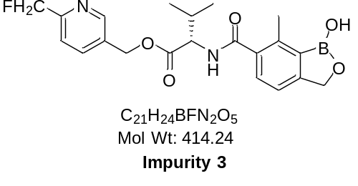
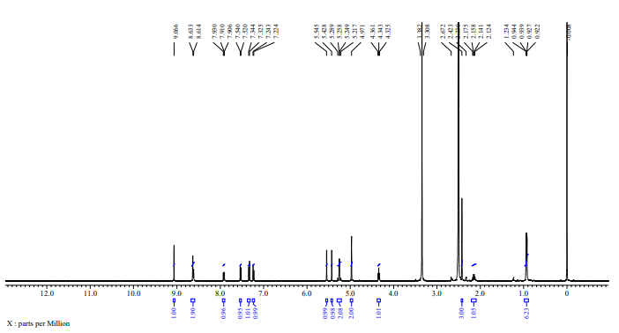

Annexure-2 (HPLC chromatogram of Impurity-3):
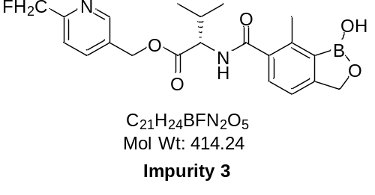
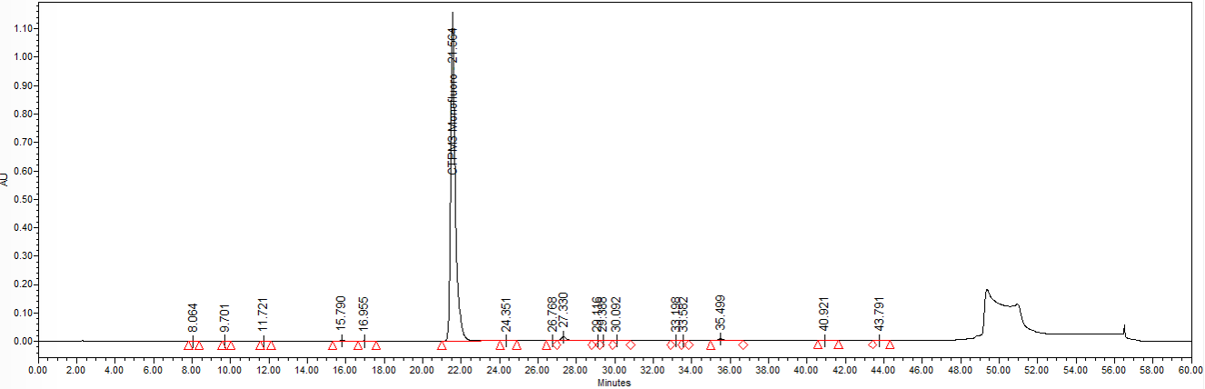

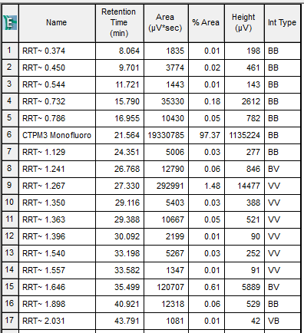

Annexure-3 (¹H-NMR spectrum of Impurity-4):
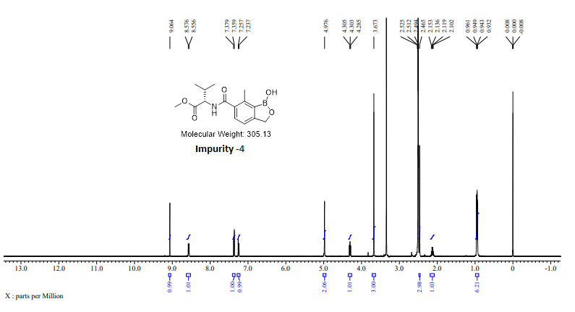

Annexure-4 (HPLC chromatogram of Impurity-4):
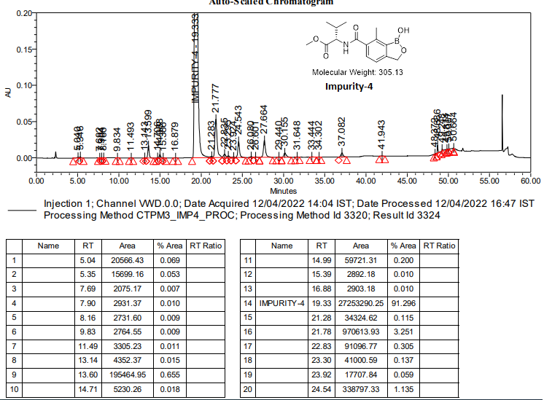

Annexure-5 (¹H-NMR spectrum of Impurity-6):
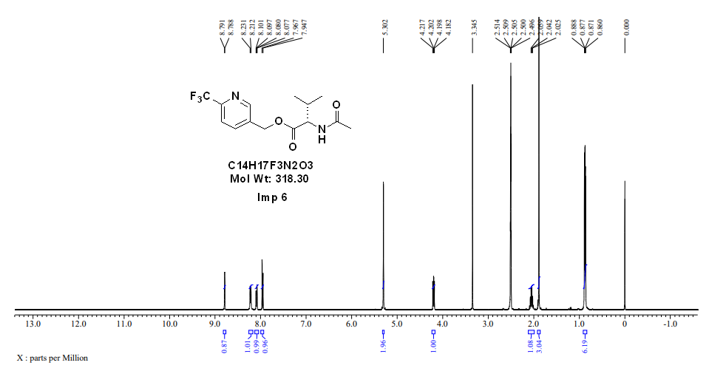

Annexure-6 (HPLC chromatogram of Impurity-6):
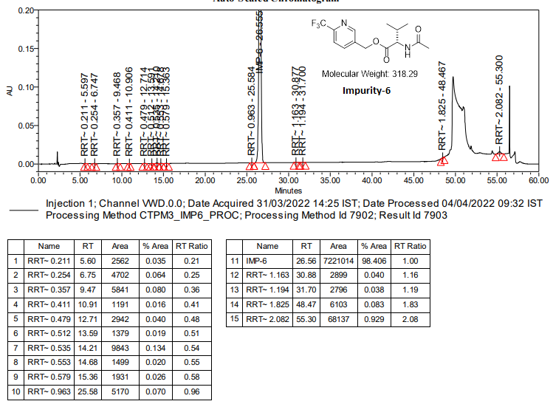

Annexure-7 (¹H-NMR spectrum of Impurity-8):
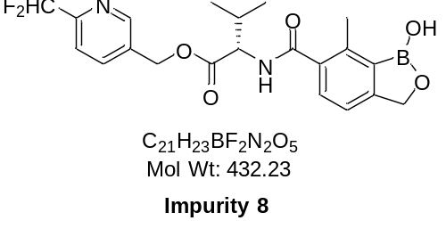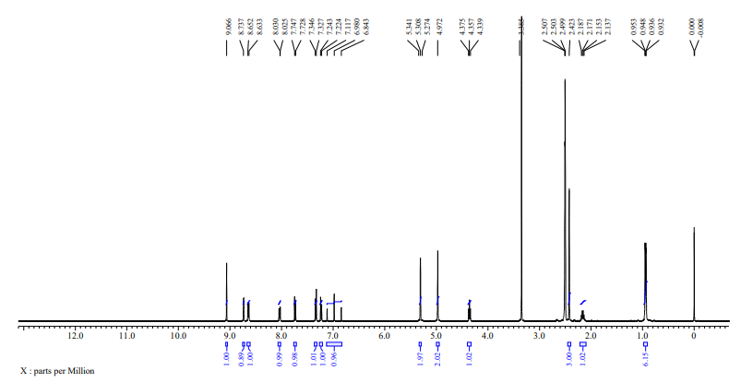

Annexure-8 (HPLC chromatogram of Impurity-8):

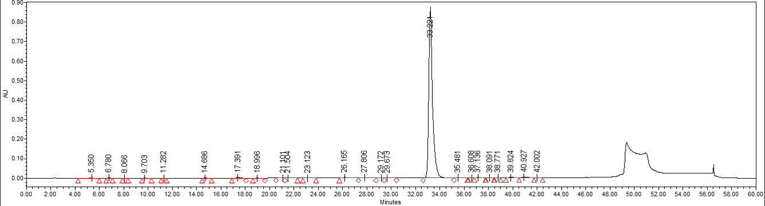
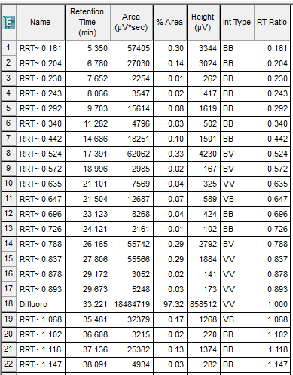

Annexure-9 (¹H-NMR spectrum of Impurity-9):
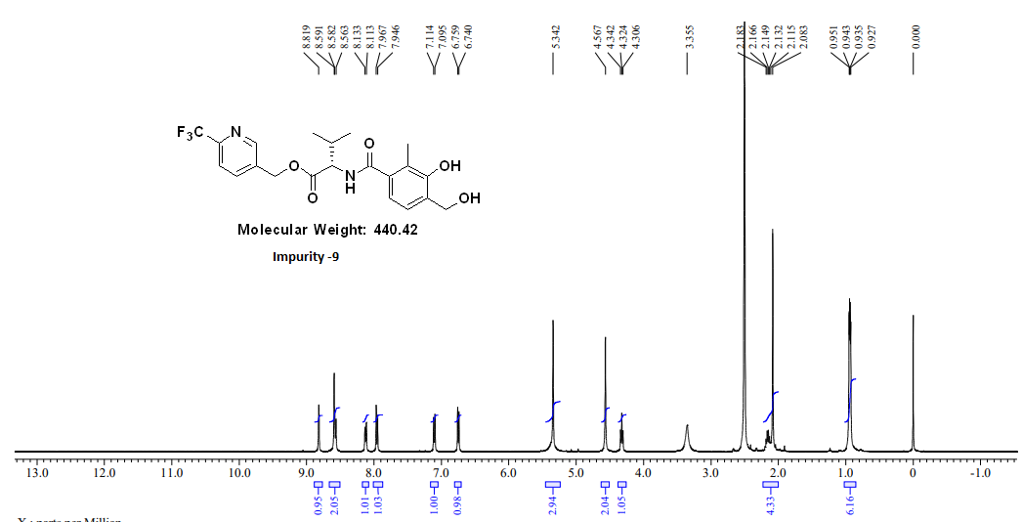

Annexure-10 (HPLC chromatogram of Impurity-9):

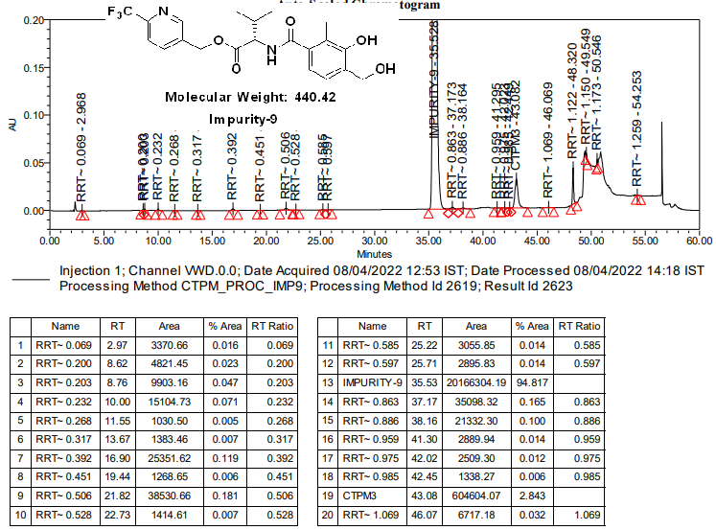

Annexure-11 (¹H-NMR spectrum of Impurity-10):
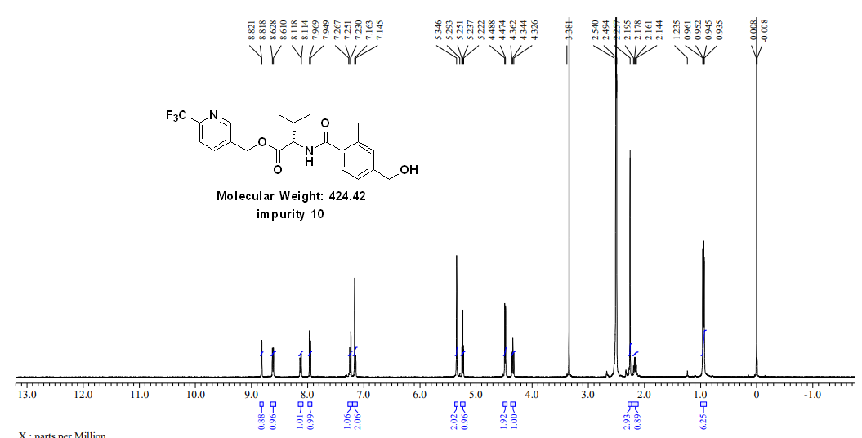

Annexure-12 (HPLC chromatogram of Impurity-10):

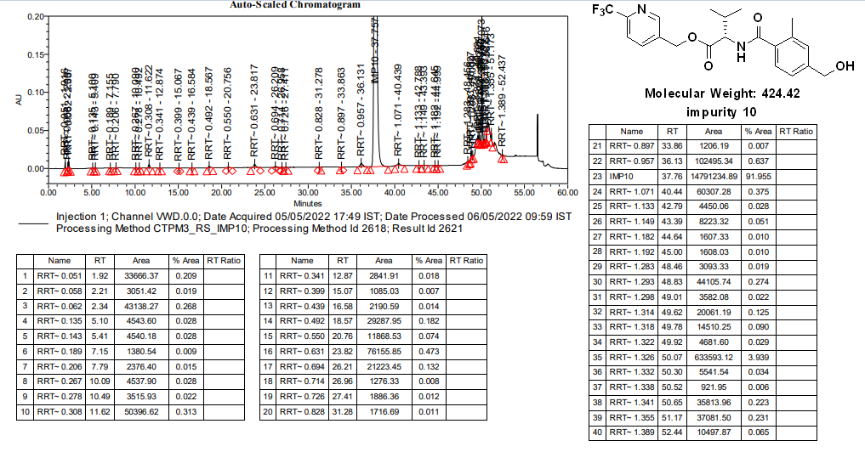

Annexure-13 (¹H-NMR spectrum of Impurity-12a):
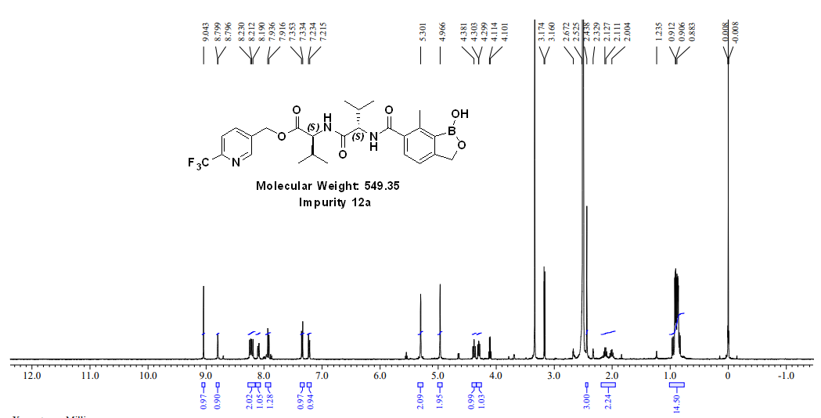

Annexure-14 (HPLC chromatogram of Impurity-12a):
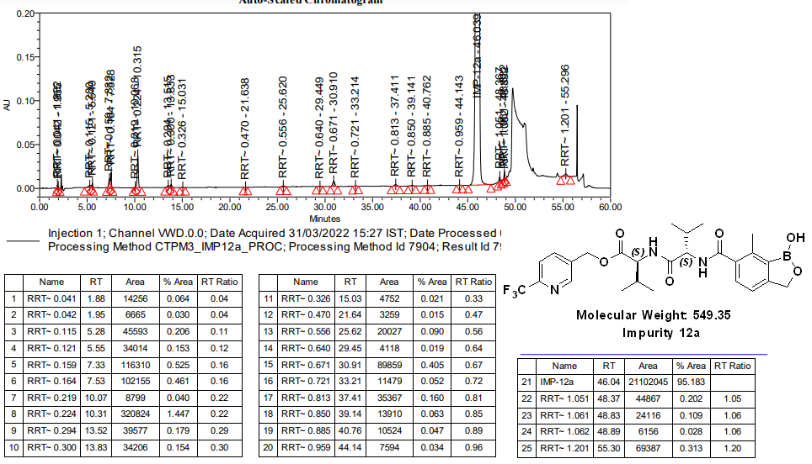

Annexure-15 (¹H-NMR spectrum of Impurity-12b):
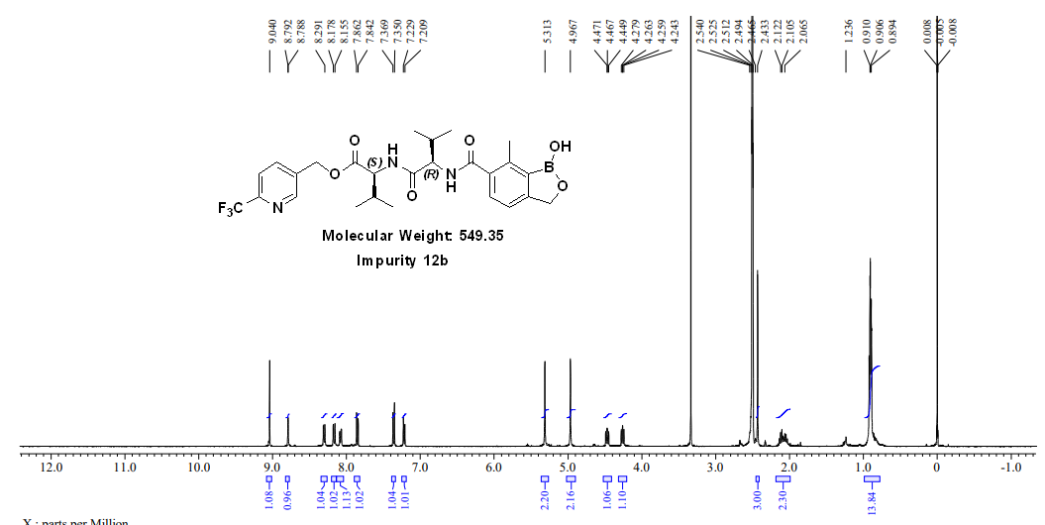

Annexure-16 (HPLC chromatogram of Impurity-12b):

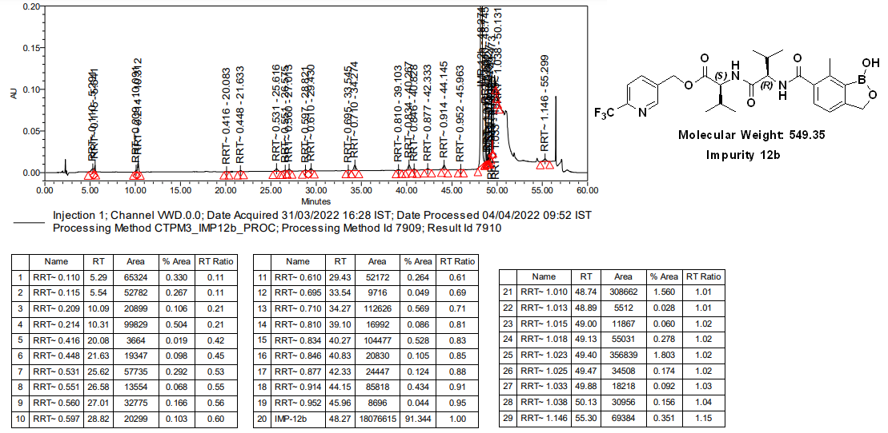

Annexure 17 (1H-NMR spectrum of Impurity-7):

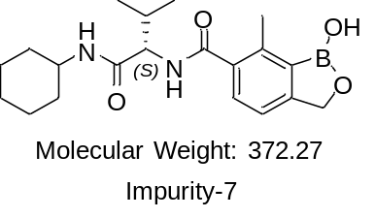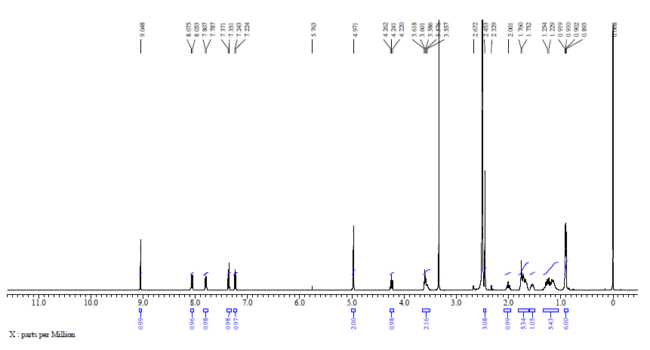

Annexure 18 (HPLC chromatogram of Impurity-7):

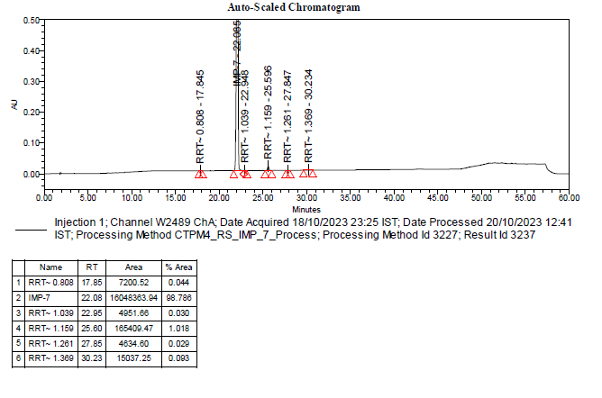

Annexure 19 (Mass spectrum of Impurity-3):

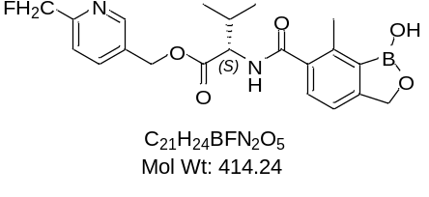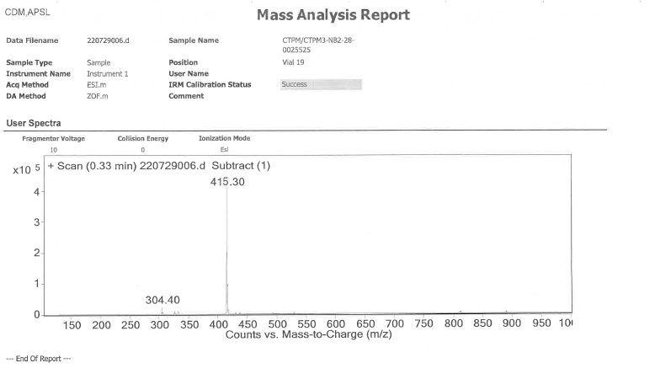

Annexure 20 (Mass spectrum of Impurity-4):

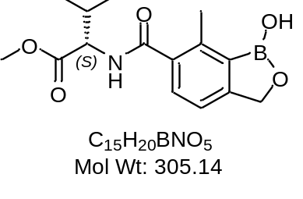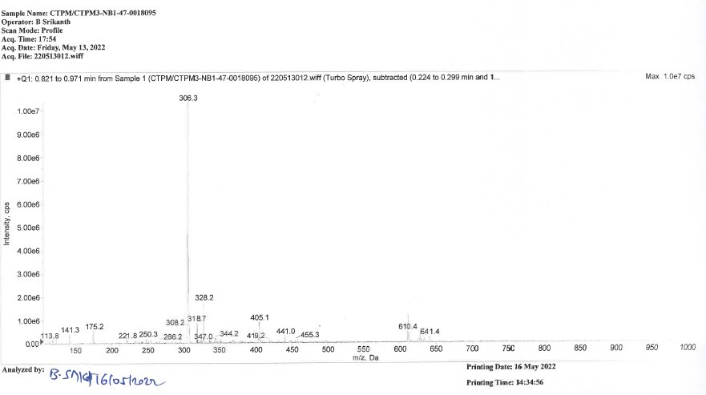

Annexure 21 (Mass spectrum of Impurity-6):

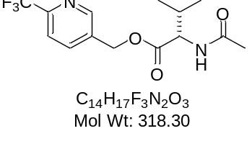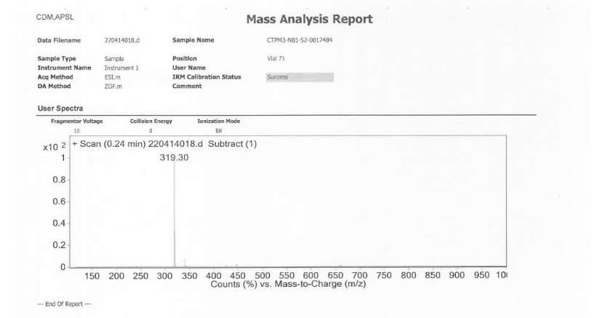

Annexure 22 (Mass spectrum of Impurity-8):

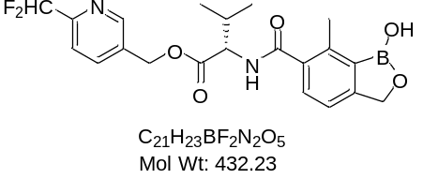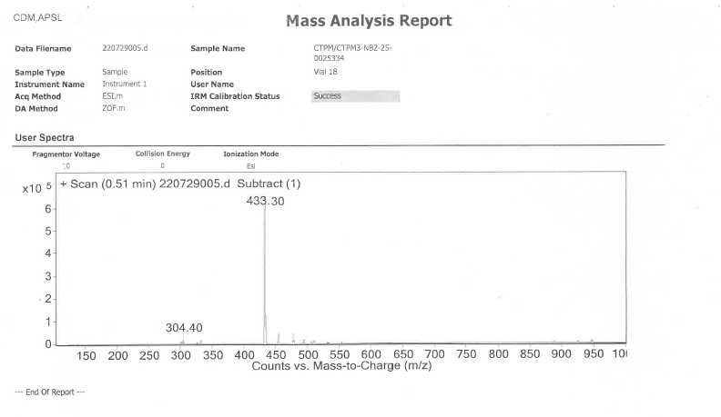

Annexure 23 (Mass spectrum of Impurity-9):

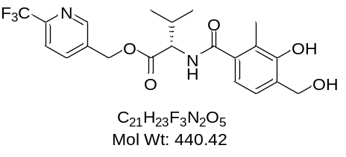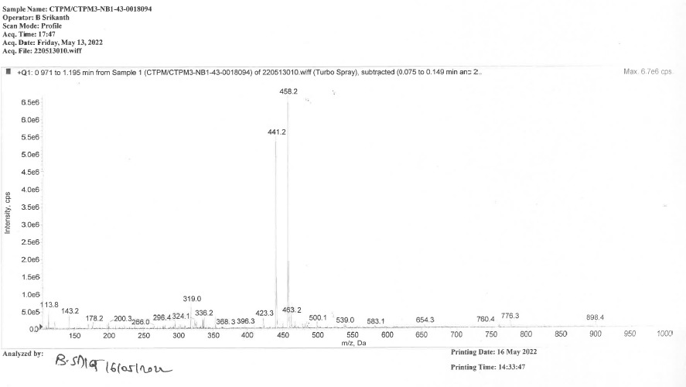

Annexure 24 (Mass spectrum of Impurity-10):

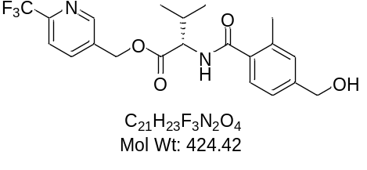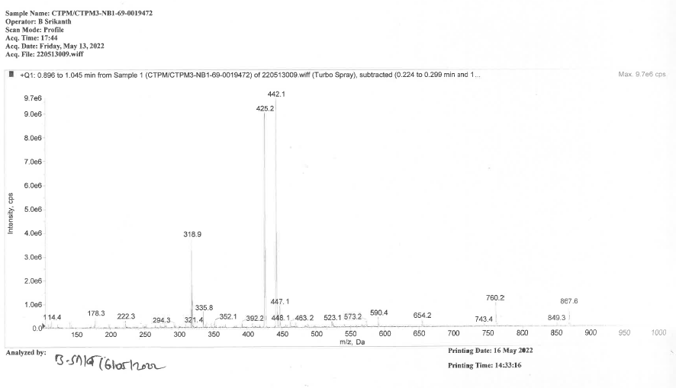

Annexure 25 (Mass spectrum of Impurity-12a):

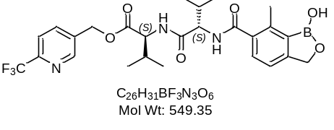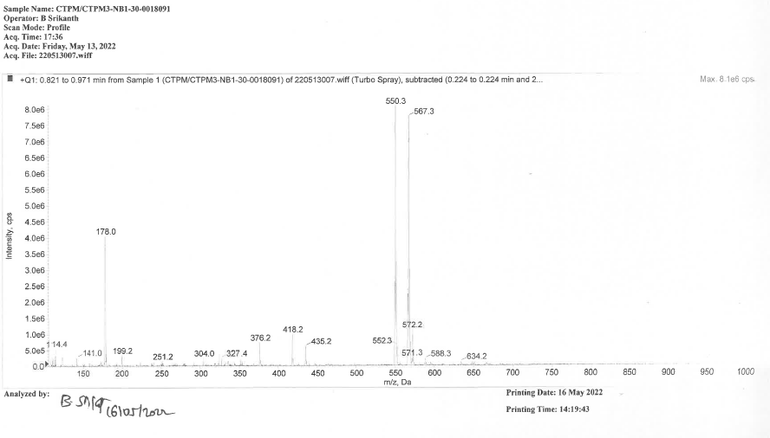

Annexure 26 (Mass spectrum of Impurity-12b):

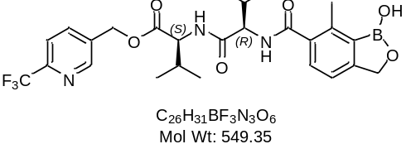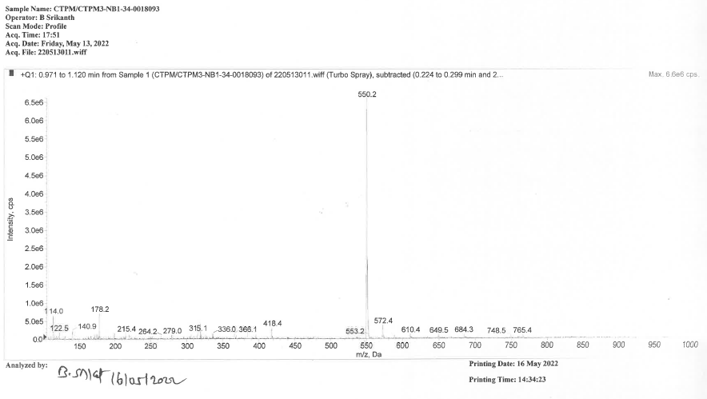

Annexure 27 (Mass spectrum of Impurity-7):

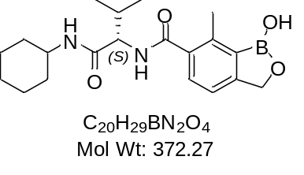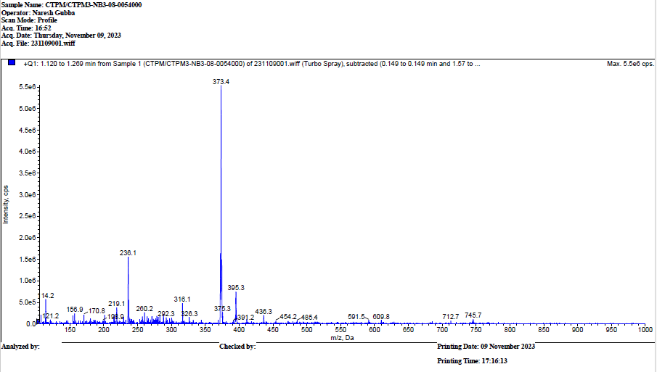
Revision History:

Document No. | Change History | Change Control  No.
RP-CDM-002004  (Version 1.0) | New CTPM3 impurity synyhesis and purging report prepared and in line with current SOP. | NA
RP-CDM-002004  (Version 2.0) | CTPM3 impurity synyhesis and purging report has been revised by correcting Impurity-17 IUPAC name and stucture in section 5.0 and 6.12. | CC1000158810

